KS3 Reading Options

Year Seven
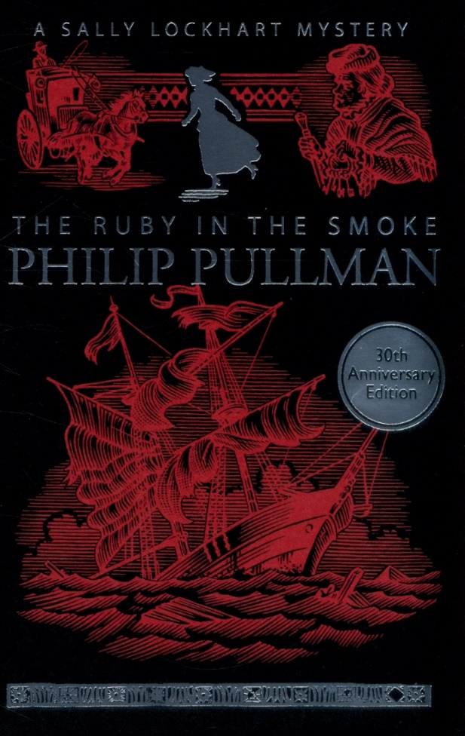

The Ruby In The Smoke

Sally is sixteen and uncommonly pretty. Her knowledge of English literature, French, history, art and music is non-existent, but she has a thorough grounding in military tactics, can run a business, ride like a Cossack and shoot straight with a pistol.
When her dear father is drowned in suspicious circumstances in the South China Sea, Sally is left to fend for herself, an orphan and alone in the smoky fog of Victorian London. Though she doesn't know it, Sally is already in terrible danger. Soon the mystery and the danger will deepen - and at the rotten heart of it all lies the deadly secret of the ruby in the smoke...

Class Readers:
In Darkling Wood
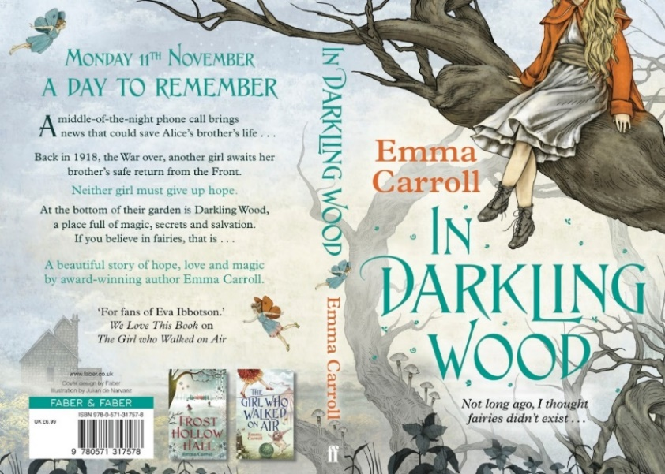
'You're telling me there are fairies in this wood?'

When Alice's brother gets a longed-for chance for a heart transplant, Alice is suddenly bundled off to her estranged grandmother's house. There's nothing good about staying with Nell, except for the beautiful Darkling Wood at the end of her garden - but Nell wants to have it cut down. Alice feels at home there, at peace, and even finds a friend, Flo. But Flo doesn't seem to go to the local school and no one in town has heard of a girl with that name. When Flo shows Alice the surprising secrets of Darkling Wood, Alice starts to wonder, what is real? And can she find out in time to save the wood from destruction?
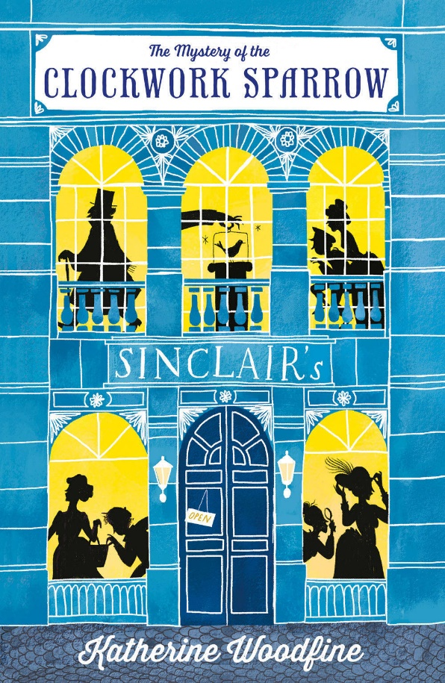
The Mystery of the Clockwork Sparrow
You are cordially invited to attend the Grand Opening of Sinclair’s department store!
Enter a world of bonbons, hats, perfumes and MYSTERIES around every corner. WONDER at the daring theft of the priceless CLOCKWORK SPARROW! TREMBLE as the most DASTARDLY criminals in London enact their wicked plans! GASP as our bold heroines, Miss Sophie Taylor and Miss Lilian Rose, CRACK CODES, DEVOUR ICED BUNS and vow to bring the villains to justice…

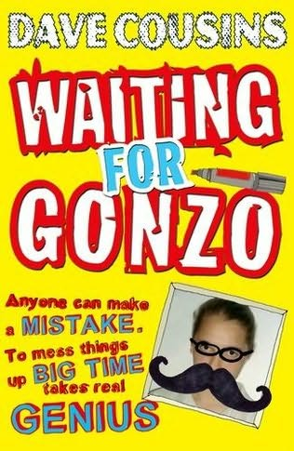
Waiting For Gonzo
Meet Oz . . . he's got a talent for trouble but his heart's always in the right place (well, nearly always).
Uprooted from his friends and former life, Oz finds himself stranded in the sleepy village of Slowleigh. When a joke backfires on the first day at his new school, Oz attracts the attention of Isobel Skinner, the school psycho - but that's just the beginning.
After causing an accident that puts his mum in hospital, Oz isn't exactly popular at home either. His older sister's no help, but then she's got a problem of her own . . . one that's growing bigger by the day.
Oz knows he's got to put things right, but life isn't that simple, especially when the only people still talking to you are a hobbit-obsessed kid and a voice in your own head!
Packed with action, heart and humour, Waiting for Gonzo takes you for a white-knuckle ride on the Wheel of Destiny as it careers out of control down the Hillside of Inevitability. The question is, do you go down laughing? Or grit your teeth and jump off?
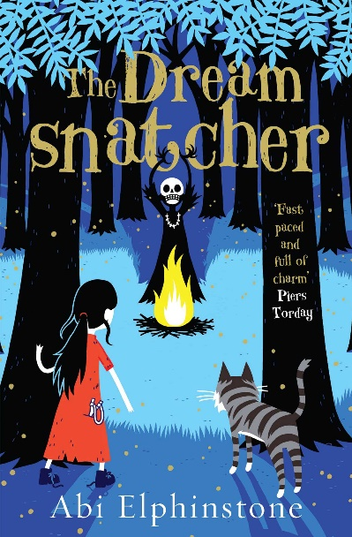
The Dreamsnatcher
Twelve-year-old Molly Pecksniff wakes one night in the middle of the forest, lured there by a recurring nightmare - the one with the drums and the rattles and the masks. The Dreamsnatcher is waiting. He has already taken her dreams and now he wants her life.
Because Moll is more important than she knows… The Oracle Bones foretold that she and Gryff, a wildcat that has always been by her side, are the only ones who can fight back against the Dreamsnatcher's dark magic. Suddenly everything is at stake, and Moll is drawn into a world full of secrets, magic and adventure.
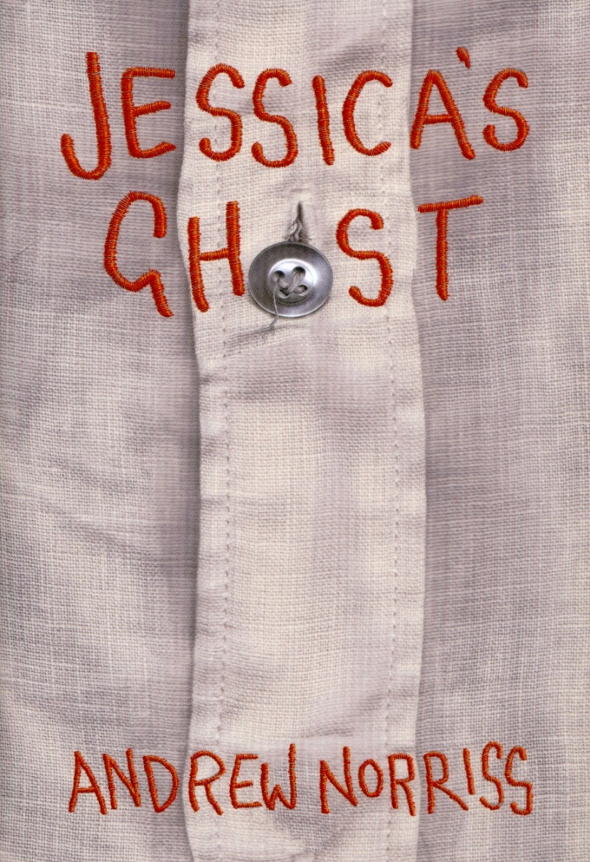
Jessica’s Ghost

Francis has never had a friend like Jessica before. She's the first person he's ever met who can make him feel completely himself. Jessica has never had a friend like Francis before. Not just because he's someone to laugh with every day - but because he's the first person who has ever been able to see her ...Jessica's Ghost is a funny, moving and beautiful book by a master storyteller, about the power of friendship to shine a warm light into dark places.

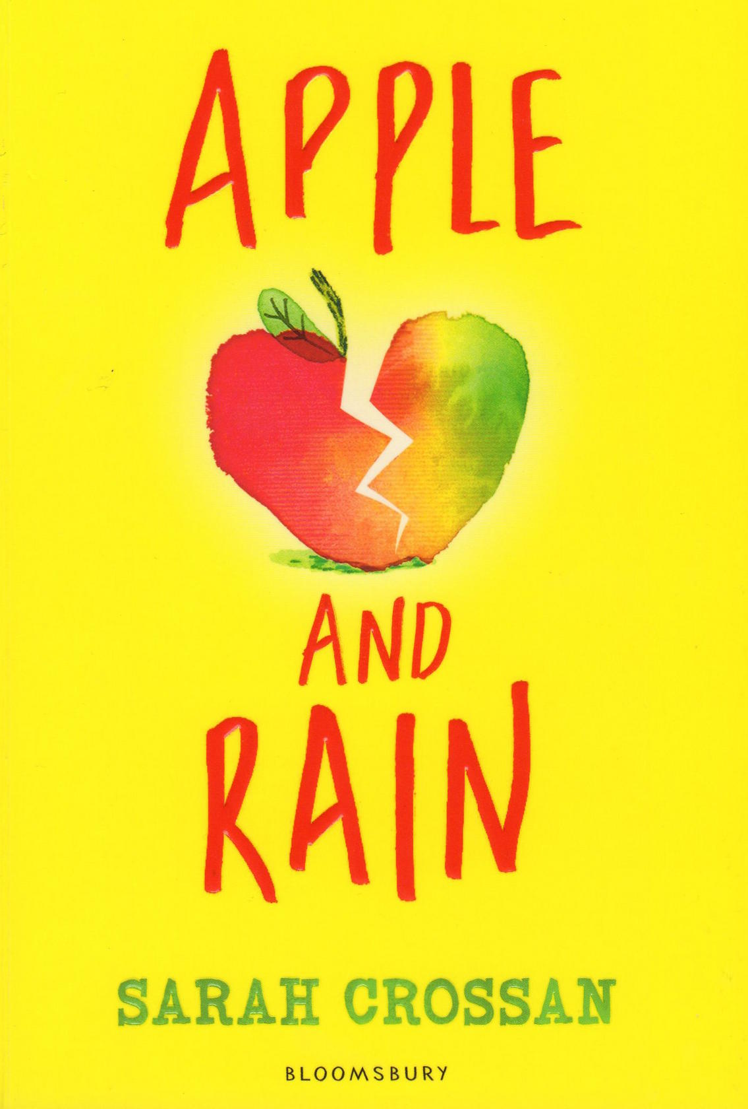
Apple and Rain

When Apple's mother returns after eleven years away, Apple feels whole again. But just like the stormy Christmas Eve when she left, her mother's homecoming is bittersweet. It's only when Apple meets someone more lost than she is that she begins to see things as they really are.
A story about sad endings.
A story about happy beginnings.
A story to make you realise who is special.

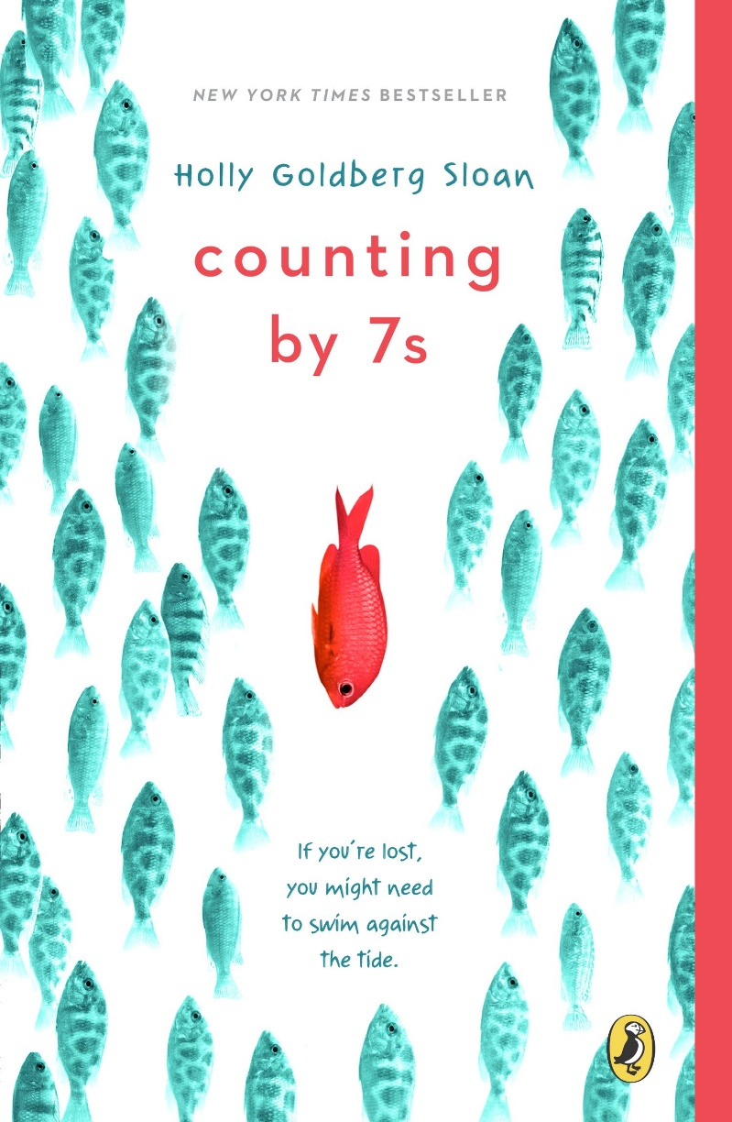
Counting by 7s

In the tradition of Out of My Mind, Wonder, and Mockingbird, this is an intensely moving middle grade novel about being an outsider, coping with loss, and discovering the true meaning of family.

Willow Chance is a twelve-year-old genius, obsessed with nature and diagnosing medical conditions, who finds it comforting to count by 7s. It has never been easy for her to connect with anyone other than her adoptive parents, but that hasn’t kept her from leading a quietly happy life . . . until now.

Suddenly Willow’s world is tragically changed when her parents both die in a car crash, leaving her alone in a baffling world. The triumph of this book is that it is not a tragedy. This extraordinarily odd, but extraordinarily endearing, girl manages to push through her grief. Her journey to find a fascinatingly diverse and fully believable surrogate family is a joy and a revelation to read.
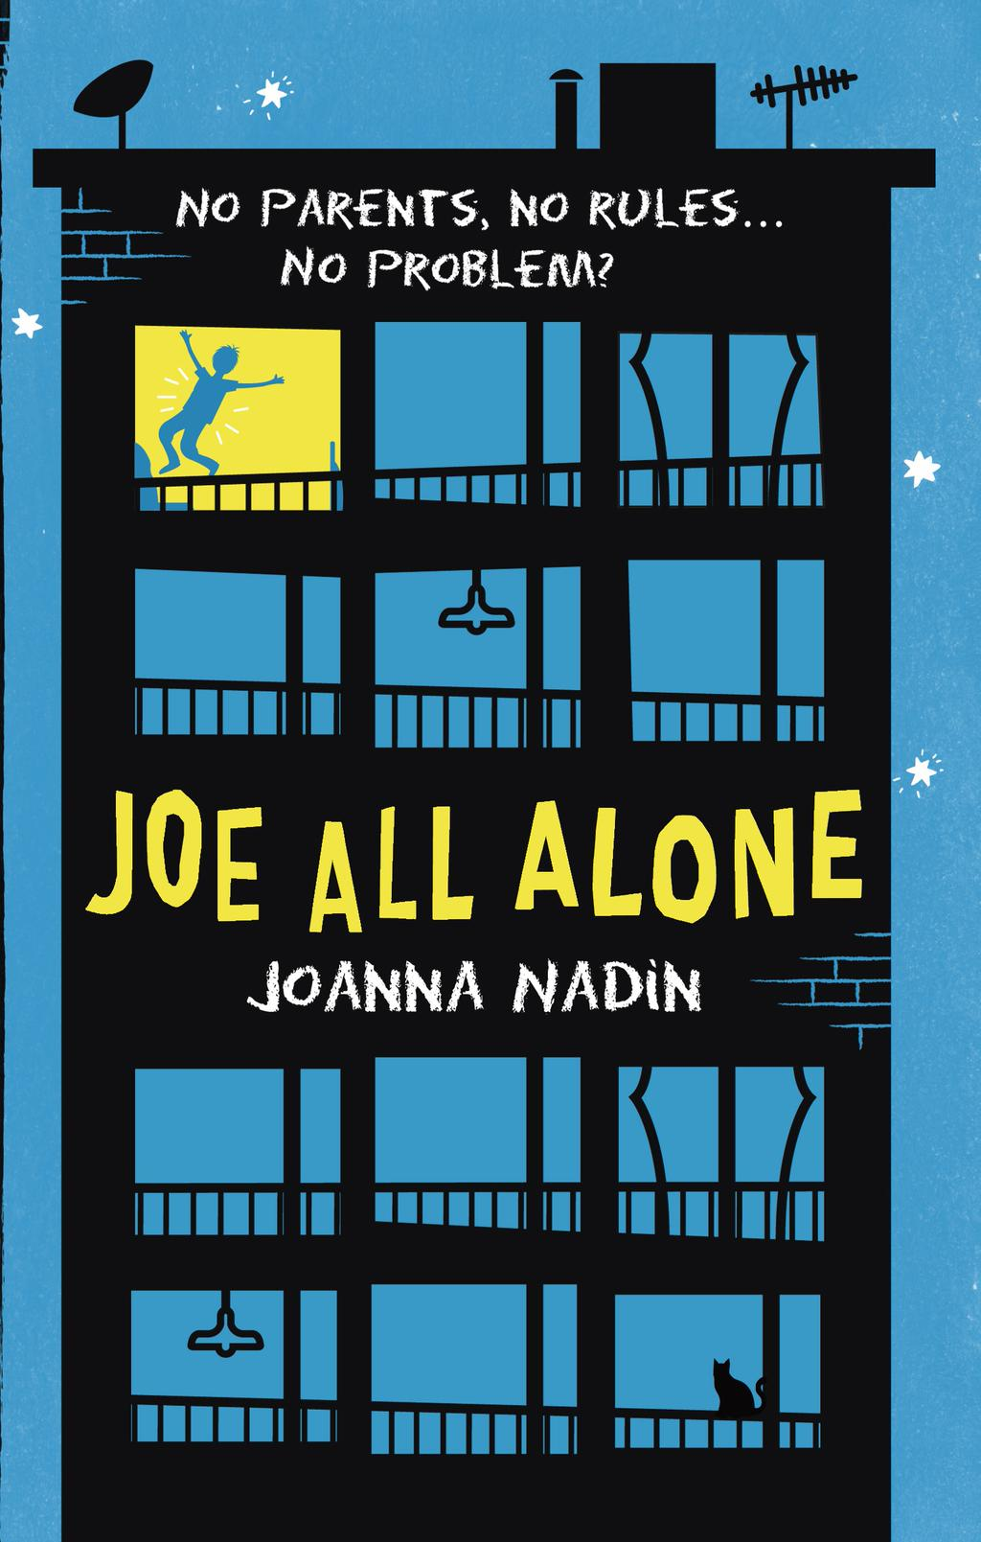
Joe All Alone

When thirteen-year-old Joe is left behind in Peckham while his mum flies to Spain on holiday, he decides to treat it as an adventure, and a welcome break from Dean, her latest boyfriend. Joe begins to explore his neighbourhood, making a tentative friendship with Asha, a fellow fugitive hiding out at her grandfather's flat.
But when the food and money run out, his mum doesn't come home, and the local thugs catch up with him, Joe realises time is running out too, and makes a decision that will change his life forever.
Deeply poignant, deceptively simple, this book will cut the reader to the bone almost without their realising it. Imogen Russell-Williams, Teens On Moon Lane
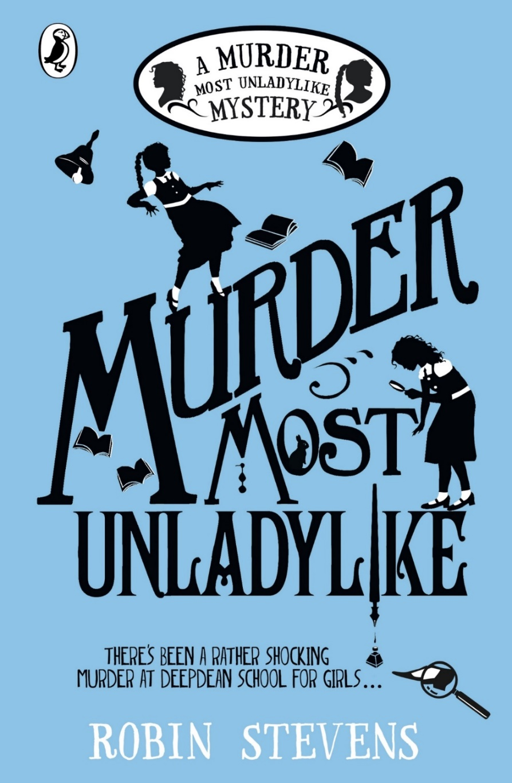
Murder Most Unladylike

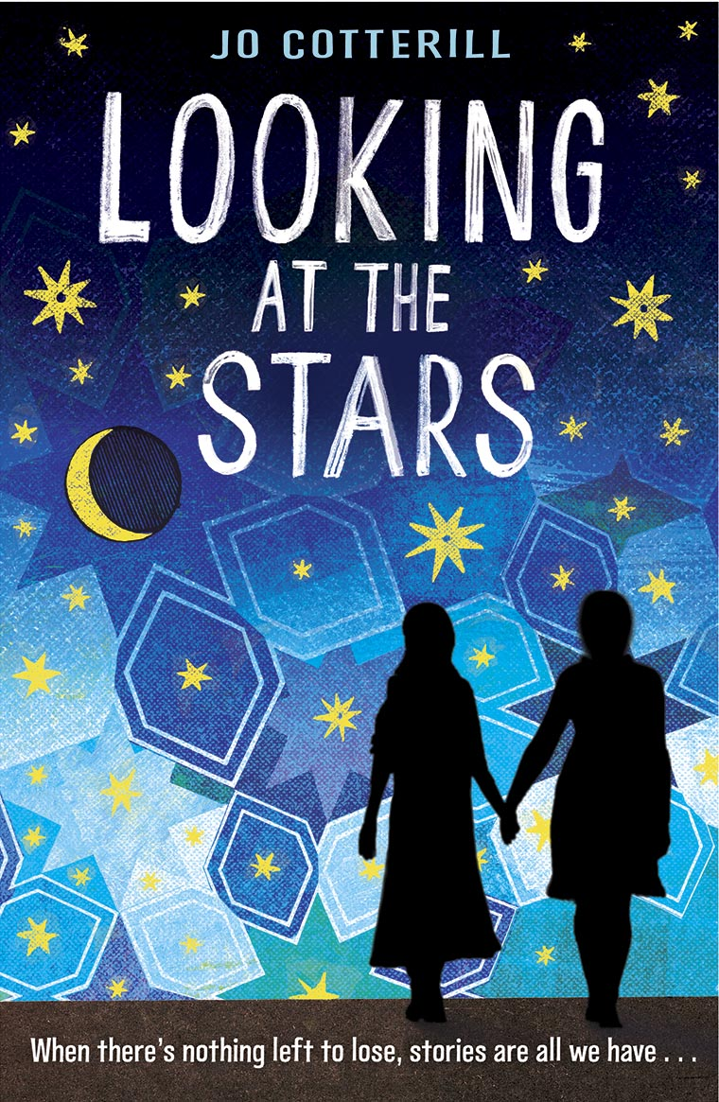
When Daisy Wells and Hazel Wong set up their very own secret detective agency at Deepdean School for Girls, they struggle to find any truly exciting mysteries to investigate. (Unless you count the case of Lavinia’s missing tie. Which they don’t.)
Then Hazel discovers the Science Mistress, Miss Bell, lying dead in the Gym. She assumes it was a terrible accident – but when she and Daisy return five minutes later, the body has disappeared. Now Hazel and Daisy not only have a murder to solve: they have to prove one happened in the first place.
Determined to get to the bottom of the crime before the killer strikes again (and before the police can get there first, naturally), Hazel and Daisy must hunt for evidence, spy on their suspects and use all the cunning and intuition they can muster. But will they succeed? And can their friendship stand the test?
Looking at the Stars

Amina’s homeland has been ravaged by war, and her family is devastated . . .
The women of the family – Amina, her two sisters and their mother – have no choice but to leave their home town, along with thousands of others, and head for a refugee camp.
But there are even more challenges ahead . . .
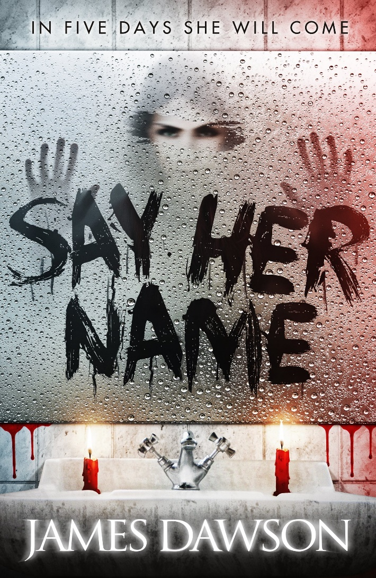
Say Her Name
Roberta 'Bobbie' Rowe is not the kind of person who believes in ghosts. A Halloween dare at her ridiculously spooky boarding school is no big deal, especially when her best friend Naya and cute local boy Caine agree to join in too. They are ordered to summon the legendary ghost of 'Bloody Mary': say her name five times in front of a candlelit mirror, and she shall appear... But, surprise surprise, nothing happens. Or does it?
Next morning, Bobbie finds a message on her bathroom mirror... five days... but what does it mean? And who left it there? Things get increasingly weird and more terrifying for Bobbie and Naya, until it becomes all too clear that Bloody Mary was indeed called from the afterlife that night, and she is definitely not a friendly ghost. Bobbie, Naya and Caine are now in a race against time before their five days are up and Mary comes for them, as she has come for countless others before... A truly spine-chilling yet witty horror from shortlisted 'Queen of Teen' author James Dawson.
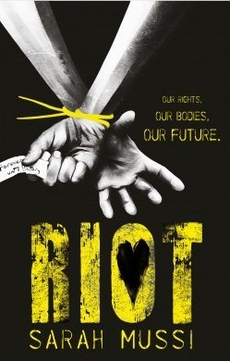
RIOT
It is 2018. England has been struggling under a recession that has shown no sign of abating. Years of cuts has devastated Britain: banks are going under, businesses closing, prices soaring, unemployment rising, prisons overflowing. The authorities cannot cope. And the population has maxed out.
The police are snowed under. Something has to give. Drastic measures need taking.
The solution: forced sterilisation of all school leavers without secure further education plans or guaranteed employment.
The country is aghast. Families are distraught, teenagers are in revolt, but the politicians are unshakeable: The population explosion must be curbed. No more free housing for single parents, no more child benefit, no more free school meals, no more children in need. Less means more.
But it is all so blatantly unfair - the Teen Haves will procreate, the Teen Havenots won't.
It's time for the young to take to the streets. It's time for them to RIOT:
OUR RIGHT TO CHOOSE, OUR BODIES, OUR FUTURE
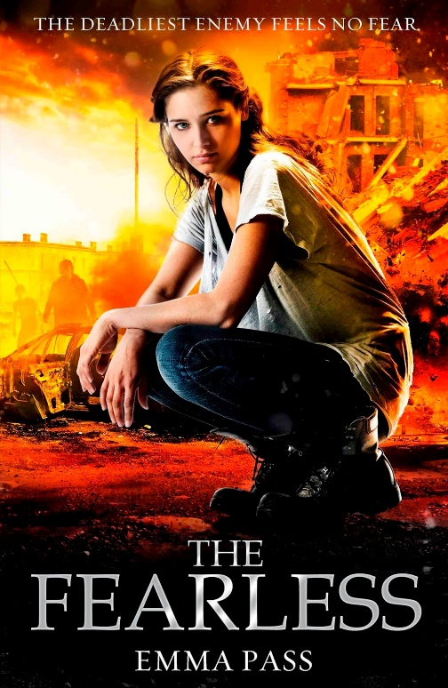
The Fearless

The Fearless. An army, powered by an incredible new serum that makes each soldier stronger, sharper, faster than their enemies. Intended as a force for good, the serum has a terrible side-effect - anyone who takes it is stripped of all humanity, empathy, love. And as the Fearless sweep through the country, forcing the serum on anyone in their path, society becomes a living nightmare.
Cass remembers the night they passed through her village. Her father was Altered. Her mother died soon after. All Cass has left is her little brother - and when Jori is snatched by the Fearless and taken to their hellish lair, Cass must risk everything to get him back.

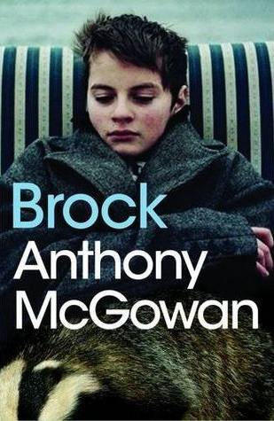
Brock
A bleakly poetic tale about one boy's determination to save a badger cub from the destructive hands of a local gang. When Nicky finds Jezbo and his gang digging up a badger set, there's not a lot he can do to save them. But one badger cub has escaped - can Nicky save it? Another stunning and moving novella in the spirit of Kes from award-winning Anthony McGowan. Particularly suitable for struggling, reluctant and dyslexic readers of 12+
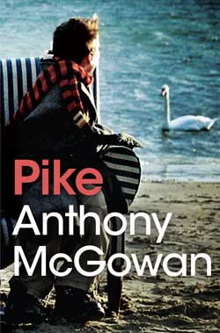
Pike
A stunning companion piece to Brock from award-winning Anthony McGowan. Nicky and Kenny return in Pike as a fishing expedition nosedives into near tragedy. The Bacon Pond is famous for its monster-sized fish and Kenny is determined to catch one. And as usual, Nicky is dragged along for the ride. But when the boys glimpse what could be a body in the water - the body of a well-known local criminal who's just been announced missing - the secrets of the Bacon Pond might just take them all down. Sometimes it's better not to look too deep. A poignant and powerful sequel to Carnegie longlisted Brock. Particularly suitable for struggling, reluctant and dyslexic readers aged 12+
Year Eight
An Island of Our Own
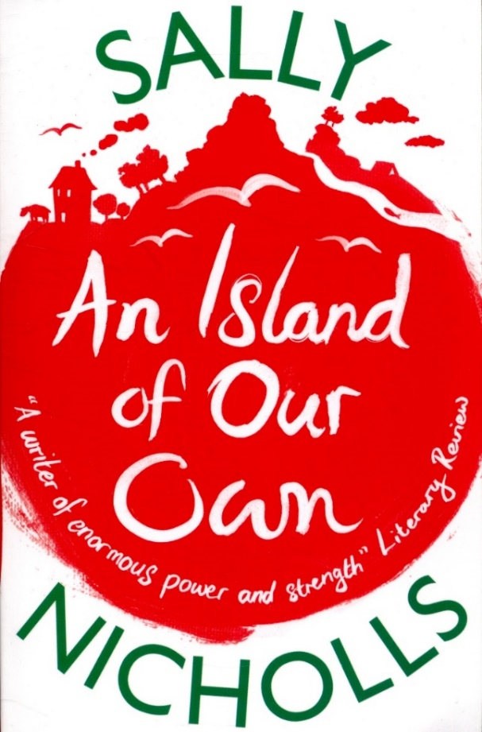
From one of the brightest talents in children's fiction and the winner of the Waterstones Children's Book prize comes a new novel about family and friendship. Siblings Jonathan, Holly and Davy have been struggling to survive since the death of their mother, and are determined to avoid being taken into care. When the family's wealthy but eccentric Great-Aunt Irene has a stroke, they go to visit her. Unable to speak or write, she gives Holly some photographs that might lead them to an inheritance that could solve all their problems. But they're not the only ones after the treasure...
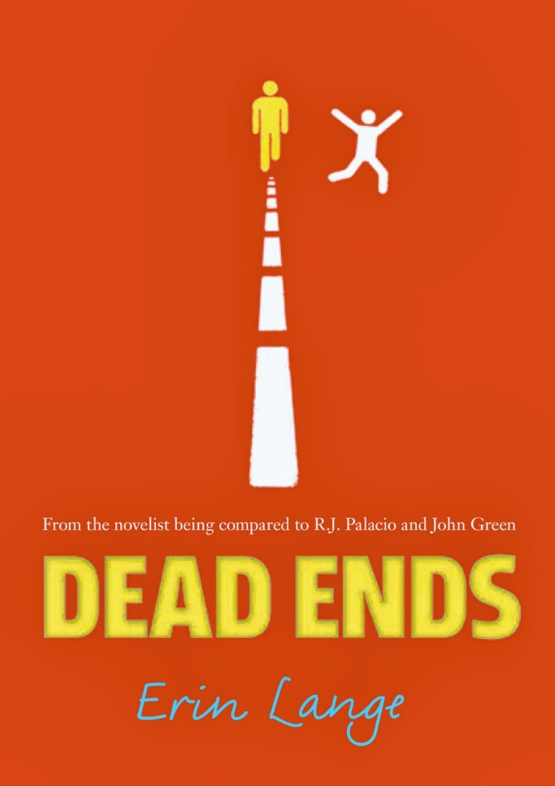
Dead Ends
Dane Washington is one suspension away from expulsion. In a high school full of “haves,” being a “have not” makes Dane feel like life is hurtling toward one big dead end. Billy D. spends his high school days in Special Ed and he’s not exactly a “have” himself. The biggest thing Billy’s missing? His dad. Billy is sure the riddles his father left in an atlas are really clues to finding him again and through a bizarre turn of events, he talks Dane into joining him on the search.
A bully and a boy with Down syndrome makes for an unlikely friendship, but together, they work through the clues, leading to unmarked towns and secrets of the past. But they’re all dead ends. Until the final clue . . . and a secret Billy shouldn’t have been keeping.
As a journalist, Erin Jade Lange is inspired by hot button issues like bullying, but it is her honest characters and breakneck plotting that make Dead Ends a must-read.
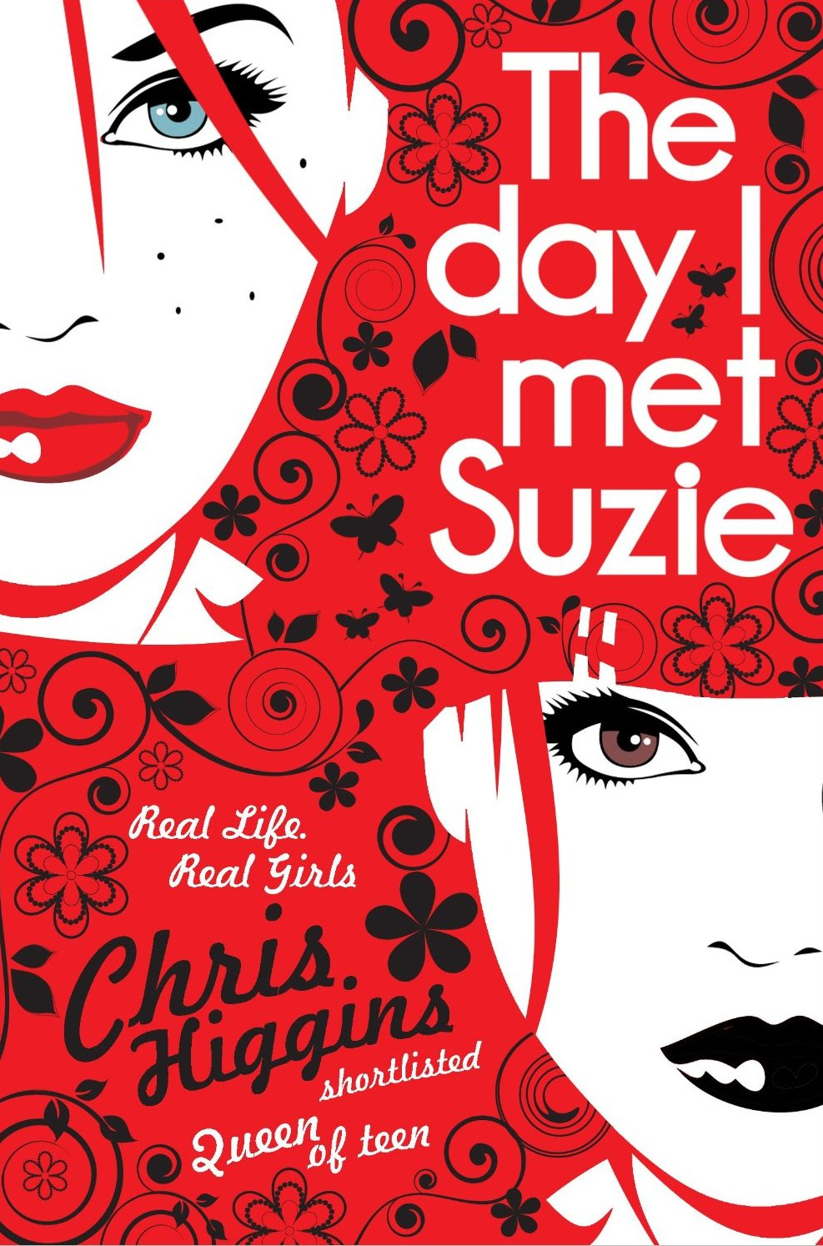
The Day I Met Suzie
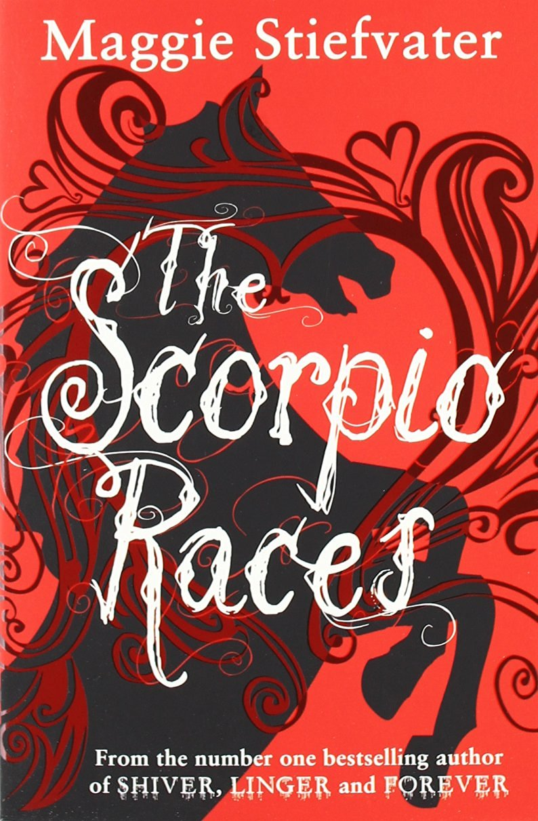
'My boyfriend could get into trouble if he gets caught. He could go to jail.' I moan softly. 'So could I.' 'Anything you tell me is completely confidential.' I sigh deeply. What have I got to lose? 'I wouldn't know where to begin.' 'At the beginning?' she says. 'In your own words.' So that's what I do. I start at the beginning like she says. The day I met Suzie. Indigo (Indie) rings the Samaritans. She is frightened and desperate with no one to turn to. Over the course of one long night, Indie tells her story to the person on the end of the phone. She realises that her friend Suzie has taken over her home, her friends, her work, her boyfriend - and her life. After every few chapters we are brought back to the present moment, and see how piecing the story together helps Indie progress towards resolution.
The Scorpio Races

It happens at the start of every November: the Scorpio Races. Riders attempt to keep hold of their water horses long enough to make it to the finish line. Some riders live. Others die.
At age nineteen, Sean Kendrick is the returning champion. He is a young man of few words, and if he has any fears, he keeps them buried deep, where no one else can see them.
Puck Connolly is different. She never meant to ride in the Scorpio Races. But fate hasn’t given her much of a chance. So she enters the competition — the first girl ever to do so. She is in no way prepared for what is going to happen
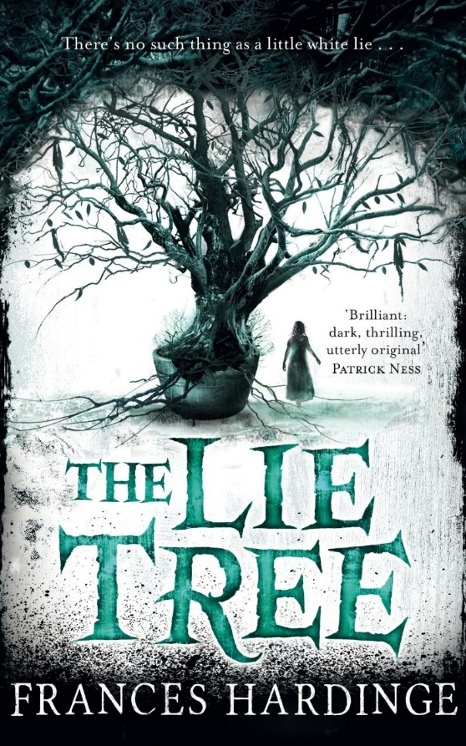
The Lie Tree

The Lie Tree is a wonderfully evocative and atmospheric novel by Frances Hardinge, award-winning author of Cuckoo Song and Fly By Night.
Faith's father has been found dead under mysterious circumstances, and as she is searching through his belongings for clues she discovers a strange tree. The tree only grows healthy and bears fruit if you whisper a lie to it. The fruit of the tree, when eaten, will deliver a hidden truth to the person who consumes it. The bigger the lie, the more people who believe it, the bigger the truth that is uncovered.
The girl realizes that she is good at lying and that the tree might hold the key to her father's murder, so she begins to spread untruths far and wide across her small island community. But as her tales spiral out of control, she discovers that where lies seduce, truths shatter . . .
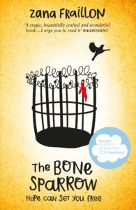
The Bone Sparrow
Shortlisted for the Guardian Children's Fiction Prize and the CILIP Carnegie Medal 2017. Perfect for fans of THE BOY IN THE STRIPED PYJAMAS. This is a beautiful, vivid and deeply moving story about a refugee boy who has spent his entire life living in a detention centre. This novel reminds us all of the importance of freedom, hope, and the power of a story to speak for anyone who's ever struggled to find a safe home. '...a special book' - Morris Gleitzman, author of the acclaimed ONCE series Born in a refugee camp, all Subhi knows of the world is that he's at least 19 fence diamonds high, the nice Jackets never stay long, and at night he dreams that the sea finds its way to his tent, bringing with it unusual treasures. And one day it brings him Jimmie. Carrying a notebook that she's unable to read and wearing a sparrow made out of bone around her neck - both talismans of her family's past and the mother she's lost - Jimmie strikes up an unlikely friendship with Subhi beyond the fence. As he reads aloud the tale of how Jimmie's family came to be, both children discover the importance of their own stories in writing their futures.

Year Nine
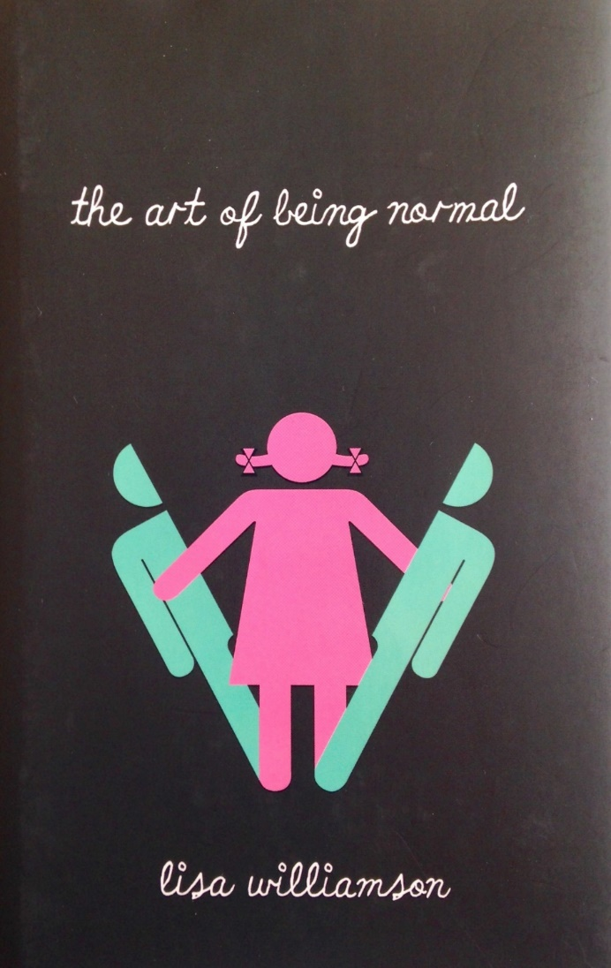
The Art Of Being Normal
Two boys. Two secrets. David Piper has always been an outsider. His parents think he's gay. The school bully thinks he's a freak. Only his two best friends know the real truth - David wants to be a girl. On the first day at his new school Leo Denton has one goal - to be invisible. Attracting the attention of the most beautiful girl in year 11 is definitely not part of that plan. When Leo stands up for David in a fight, an unlikely friendship forms. But things are about to get messy. Because at Eden Park School secrets have a funny habit of not staying secret for long ...
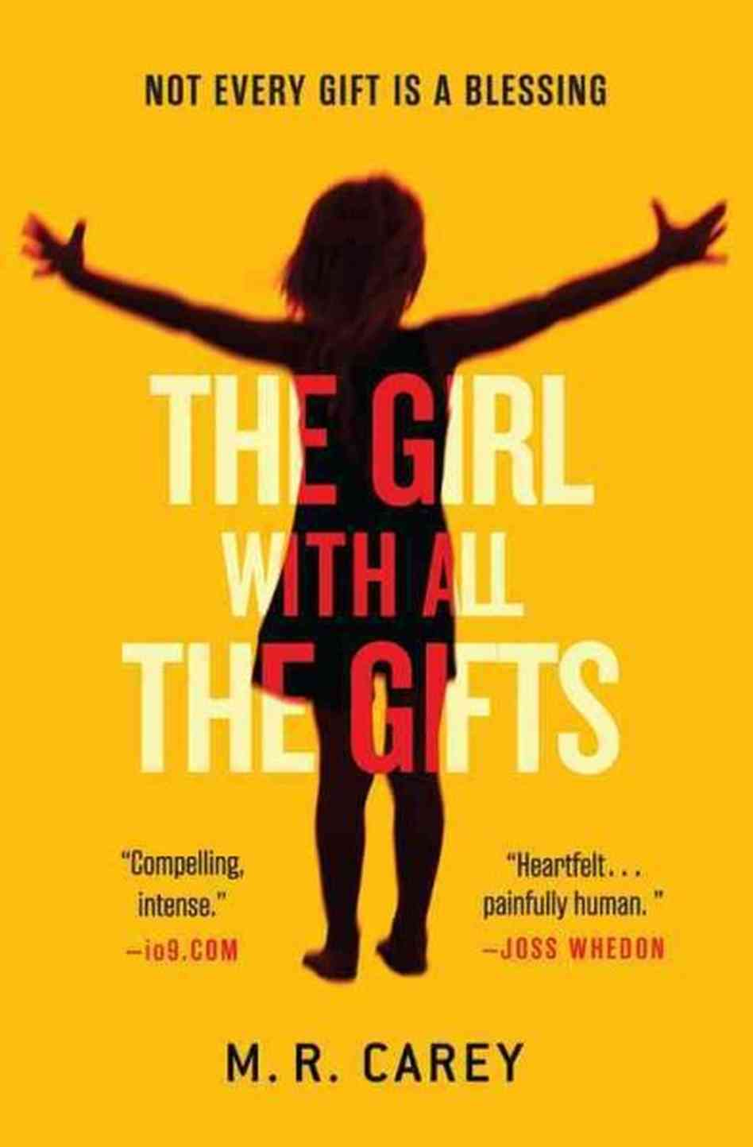
The Girl With All The Gifts
Every morning, Melanie waits in her cell to be collected for class.

When they come for her, Sergeant Parks keeps his gun pointing at her while two of his people strap her into the wheelchair. She thinks they don't like her. She jokes that she won't bite. But they don't laugh.

Melanie is a very special girl.
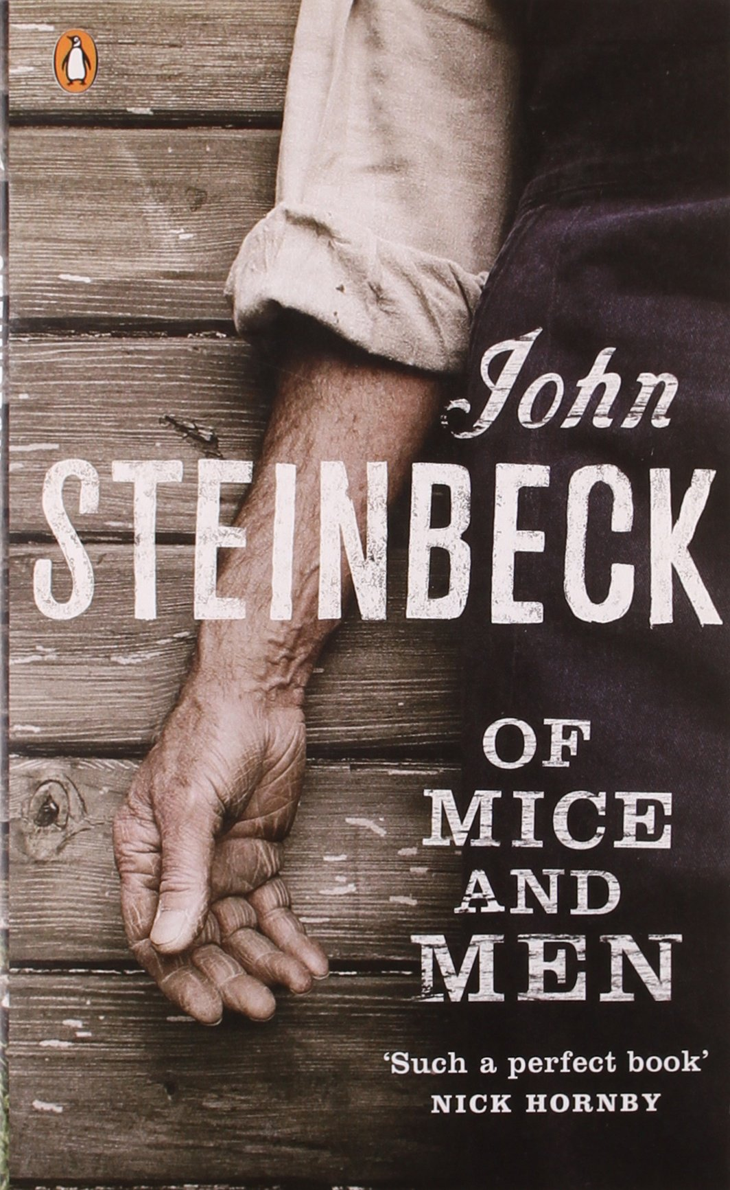
Of Mice and Men
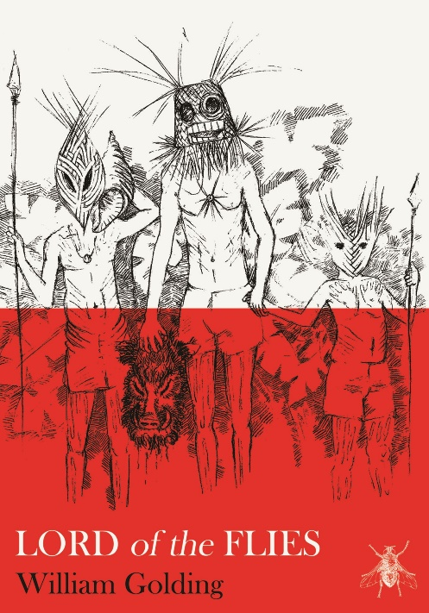
Of Mice and Men (1937) is a novella written by John Steinbeck (1902 – 1968) that tells the story of George Milton, an intelligent man with quick wit, and Lennie Small, a big man with a child’s brain. The narrative begins with the unlikely pair approaching a ranch near Soledad, California and follows their trials as George cares for Lennie. Lennie is a lot of work, the big man loves touching soft things and his appreciation of texture and monstrous strength causes him to accidentally kill soft mice and soft puppies. Though Lennie does bad things from time to time, “he never done one of ’em mean” (90). Though the pair must part ways when Lennie pays for his misdeeds, their dream of owning their own land may be comfort to Lennie as he lays in the soft dirt.
The Lord of the Flies
When a plane crashes on a remote island, a small group of schoolboys are the sole survivors. From the prophetic Simon and virtuous Ralph to the lovable Piggy and brutish Jack, each of the boys attempts to establish control as the reality - and brutal savagery - of their situation sets in.
The boys' struggle to find a way of existing in a community with no fixed boundaries invites readers to evaluate the concepts involved in social and political constructs and moral frameworks. Ideas of community, leadership, and the rule of law are called into question as the reader has to consider who has a right to power, why, and what the consequences of the acquisition of power may be. Often compared to Catcher in the Rye, Lord of the Flies also represents a coming-of-age story of innocence lost.
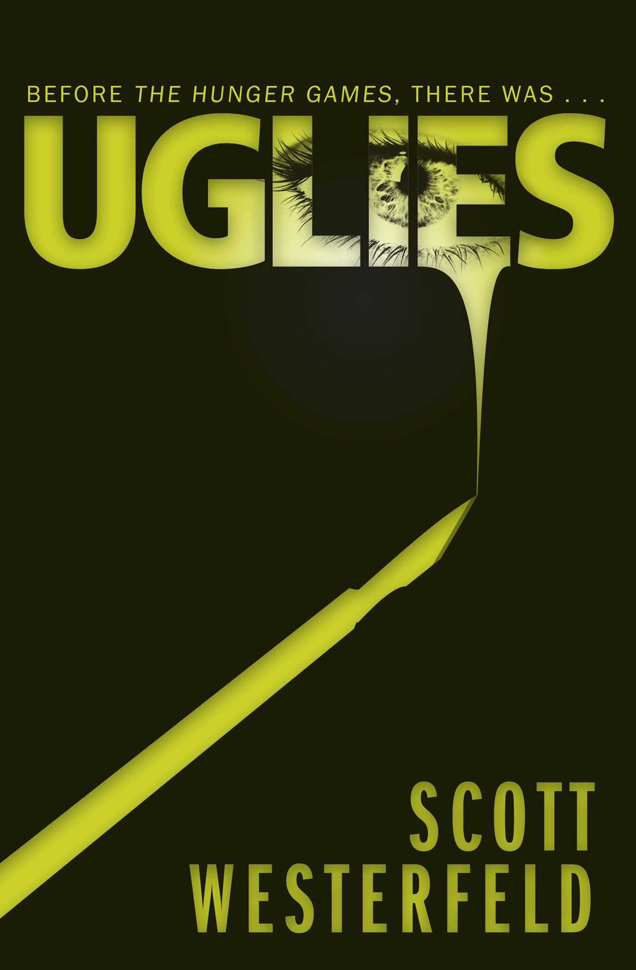
Uglies
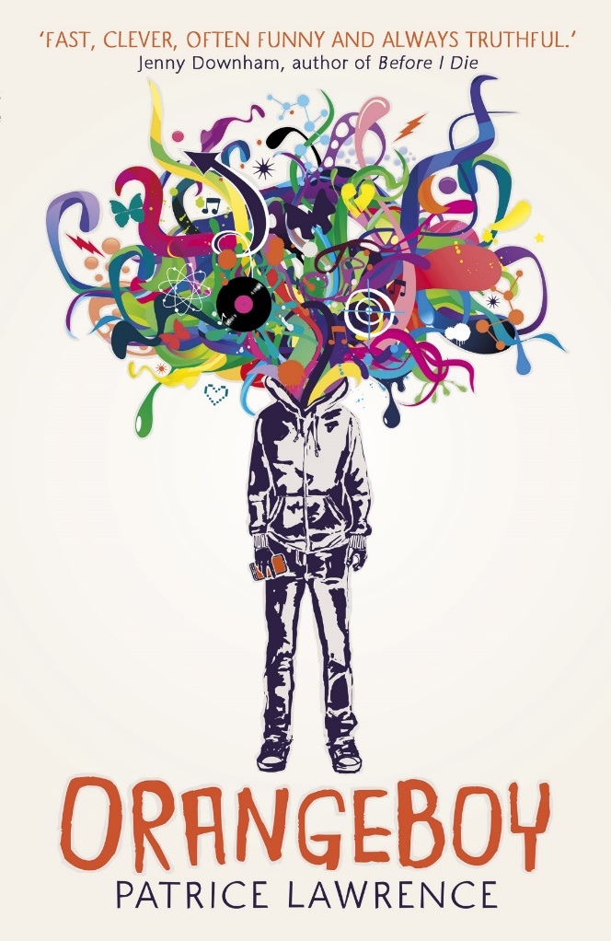
Tally is about to turn sixteen, and she can't wait. In just a few weeks she'll have the operation that will turn her from a repellent ugly into a stunning pretty. And as a pretty, she'll be catapulted into a high-tech paradise where her only job is to have fun.
But Tally's new friend Shay isn't sure she wants to become a pretty. When Shay runs away, Tally learns about a whole new side of the pretty world-- and it isn't very pretty. The authorities offer Tally a choice: find her friend and turn her in, or never turn pretty at all. Tally's choice will change her world forever...
OrangeBoy
Sixteen-year-old Marlon has promised his widowed mum that he'll be good, and nothing like his gang-leader brother Andre. It's easy when you keep yourself to yourself, listening to your dead dad's Earth, Wind and Fire albums and watching sci-fi. But everything changes when Marlon's first date with the beautiful Sonya ends in tragedy; he becomes a hunted man and he has no idea why. With his dad dead and his brother helpless, Marlon has little choice but to enter Andre's old world of guns, knives and drug runs in order to uncover the truth and protect those close to him. It's time to fight to be the last man standing.
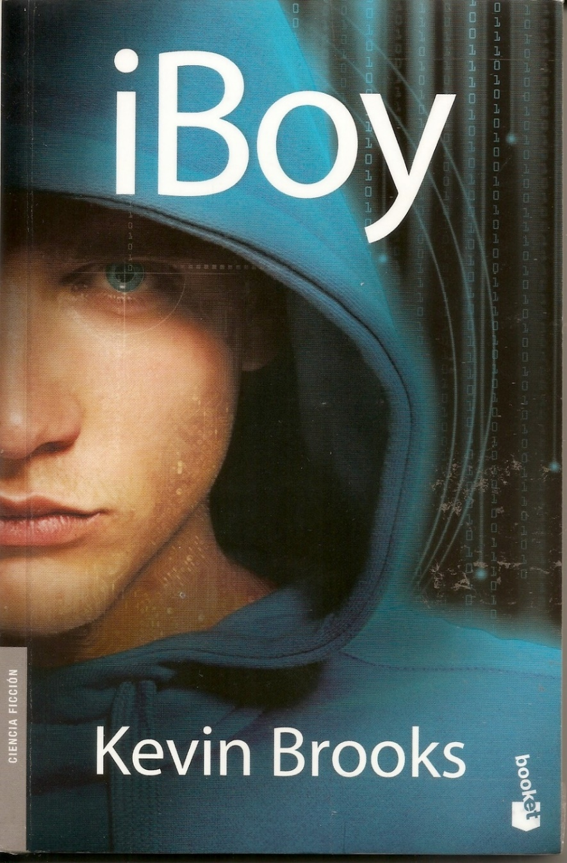
iBoy
Before the attack, sixteen-year-old Tom Harvey was just an ordinary boy.
But now fragments of a shattered iPhone are embedded in his brain and it's having an extraordinary effect...
Because now Tom has powers. The ability to know and see more than he could ever imagine. And with incredible power comes knowledge - and a choice. Seek revenge on the violent gangs that rule his estate and assaulted his friend Lucy, or keep quiet?
Tom has control when everything else is out of control. But it's a dangerous price to pay. And the consequences are terrifying. . .
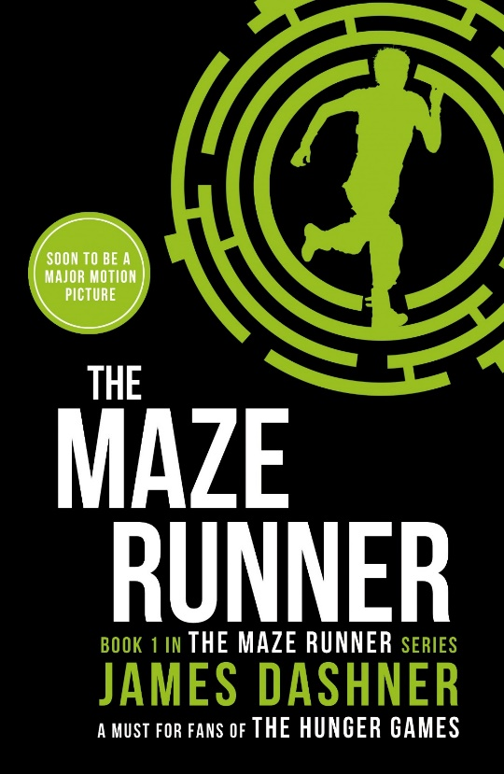
Mazerunner
If you ain’t scared, you ain’t human.
When Thomas wakes up in the lift, the only thing he can remember is his name. He’s surrounded by strangers—boys whose memories are also gone.
Nice to meet ya, shank. Welcome to the Glade.
Outside the towering stone walls that surround the Glade is a limitless, ever-changing maze. It’s the only way out—and no one’s ever made it through alive.
Everything is going to change.
Then a girl arrives. The first girl ever. And the message she delivers is terrifying.
Remember. Survive. Run.
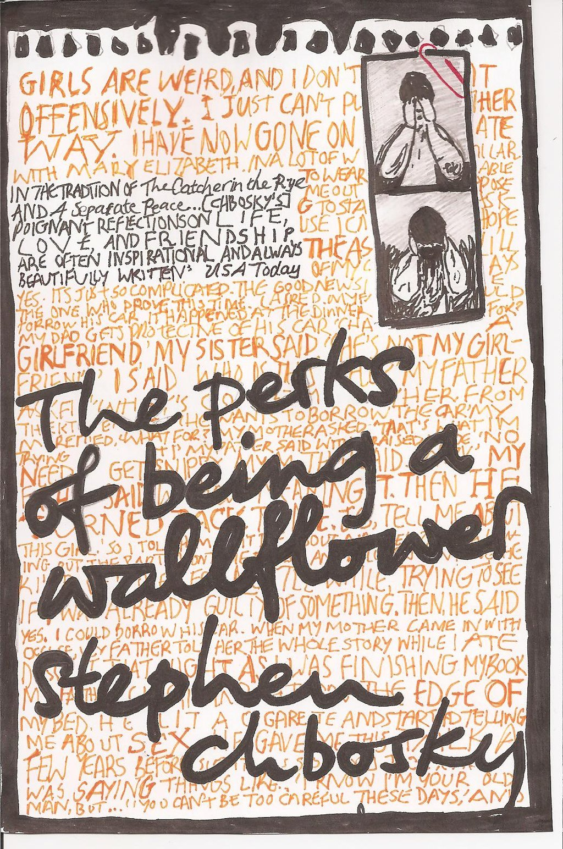
The Perks of Being a Wallflower
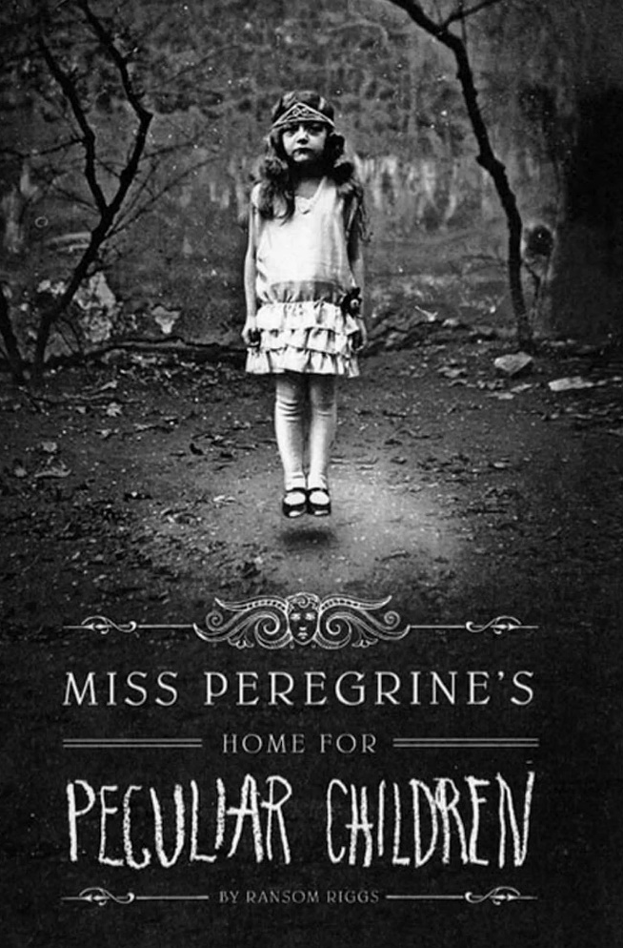
Charlie is a freshman.
And while he's not the biggest geek in the school, he is by no means popular. Shy, introspective, intelligent beyond his years yet socially awkward, he is a wallflower, caught between trying to live his life and trying to run from it.
Charlie is attempting to navigate his way through uncharted territory: the world of first dates and mix tapes, family dramas and new friends; the world of sex, drugs, and The Rocky Horror Picture Show, when all one requires is that perfect song on that perfect drive to feel infinite. But he can't stay on the sideline forever. Standing on the fringes of life offers a unique perspective. But there comes a time to see what it looks like from the dance floor.
The Perks of Being a Wallflower is a deeply affecting coming-of-age story that will spirit you back to those wild and poignant roller-coaster days known as growing up.
Miss Peregrine’s Home for Peculiar Children
A mysterious island. An abandoned orphanage. A strange collection of curious photographs.
A horrific family tragedy sets sixteen-year-old Jacob journeying to a remote island off the coast of Wales, where he discovers the crumbling ruins of Miss Peregrine’s Home for Peculiar Children. As Jacob explores its abandoned bedrooms and hallways, it becomes clear that the children were more than just peculiar. They may have been dangerous. They may have been quarantined on a deserted island for good reason. And somehow—impossible though it seems—they may still be alive.
A spine-tingling fantasy illustrated with haunting vintage photography, Miss Peregrine's Home for Peculiar Children will delight adults, teens, and anyone who relishes an adventure in the shadows.
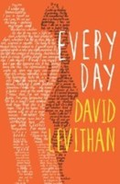
Everyday
Every day a different body. Every day a different life. Every day in love with the same girl.
There’s never any warning about where it will be or who it will be. A has made peace with that, even established guidelines by which to live: Never get too attached. Avoid being noticed. Do not interfere.
It’s all fine until the morning that A wakes up in the body of Justin and meets Justin’s girlfriend, Rhiannon. From that moment, the rules by which A has been living no longer apply. Because finally A has found someone he wants to be with—day in, day out, day after day.

